**SMART HOUSE NETWORKING**

A COURSE PROJECT REPORT

By

**GOLLAPUDI VYSHAVI(RA1911027010112)**

**K.LIKITH BARGAV(RA1911027010101)**

Under the guidance of

# Dr.VEERAMAKALI

*In partial fulfilment for the Course*

of

18CSC302J - COMPUTER NETWORKS

in

Data Science and Business Systems



**FACULTY OF ENGINEERING AND TECHNOLOGY**

**SRM INSTITUTE OF SCIENCE AND TECHNOLOGY**

# Kattankulathur, Chenpalpattu District

NOVEMBER 2021

1

# SRM INSTITUTE OF SCIENCE AND TECHNOLOGY

**(Under Section 3 of UGC Act, 1956)**

## BONAFIDE CERTIFICATE

Certified that this project report "**SMART HOUSE NETWORKING**" is the

bonafide work of **GOLLAPUDI VYSHNAVI(RA1911027010112),**

**K. LIKITH BAGAV(RA1911027010101)** who carried out the project work under my supervision.

**SIGNATURE SIGNATURE**

### Dr.E. VEERAMAKALI, Dr.E. Sashikala, Subject Staff Course Cordinator Associate Professor, Associate Professor,

**Data Science and Business Systems** **Data Science and Business Systems**

SRM Institute of Science and Technology SRM Institute of Science and Technology

Potheri, SRM Nagar, Kattankulathur, Potheri, SRM Nagar, Kattankulathur, Tamil Nadu 603203 Tamil Nadu 603203

2

**CHAPTER 1**

## ABSTRACT

Due to COVID 19, we were quarantined in our respective homes, which led to a new era in the education, job sector with the need for online classes and work from home. Hence the requirement of a high-speed internet connection at home is now inevitable. This has led to an increase in the sales of wireless routers and internet service providers. More and more people are investing in devices compatible with wireless connections and secondary devices such as printers.

As there is a rise in the demand for wireless devices and routers, it is essential that they have a planned home network design that aids their process of setting up the network at home. Therefore, with this project, we propose a SMART HOUSE NETWORKING Design that connects three users at home to high-speed Internet and a parallel printer. Devices such as wireless routers, ISP routers, and servers, along with copper cross-over and cropper straight-through cables, are proposed.

A home network design is a schematic layout of a wireless network at home with remote access from the office. It helps us plan a home-office network and figure out the best layout for it.

There are many reasons to establish a home network. Here are just a few of the things home networking allows you to do: Connect to the Internet from multiple computers, game systems, mobile devices, and more. Access files and folders on all devices connected to the network. Print from multiple computers on a single printer. Manage

security settings for all networked devices in one place.

3

### ACKNOWLEDGEMENT

We express our heartfelt thanks to our honorable **Vice Chancellor**

**Dr. C. MUTHAMIZHCHELVAN**, for being the beacon in all our endeavors.

We would like to express my warmth of gratitude to our **Registrar**

**Dr. S. Ponnusamy,** for his encouragement

We express our profound gratitude to our **Dean (College of Engineering and Technology) Dr. T. V. Gopal,** for bringing out novelty in all executions.

We would like to express our heartfelt thanks to Chairperson, School of Computing **Dr. Revathi Venkataraman,** for imparting confidence to complete my course project

We wish to express my sincere thanks to **Course Audit Professor**  **Dr.M. LAKSHMI, Professor and Head, Data Science and Business Systems** and **Course Cordinator Dr.E. Sasikala, Associate Professor, Data Science and Business Systems** for their constant encouragement and support.

We are highly thankful to our Course project Internal guide **Dr.E. Sasikala, Associate Professor, Data Science and Business Systems** for **her** assistance, timely suggestion and guidance throughout the duration of this course project.

We extend our gratitude to all Departmental colleagues for their Support.

Finally, we thank our parents and friends near and dear ones who directly and indirectly contributed to the successful completion of our project. Above all, I thank the almighty for showering his blessings on me to complete my Course project

**TABLE OF CONTENTS**

**CHAPTERS CONTENTS PAGE NO.**

1. **ABSTRACT 3**
2. **INTRODUCTION 6**
3. **REQUIREMENT ANALYSIS 8**
4. **ARCHITECTURE & DESIGN 10**
5. **IMPLEMENTATION 16**
6. **EXPERIMENT RESULTS & ANALYSIS 25** 
   1. RESULTS
   2. RESULT ANALYSIS
   3. CONCLUSION & FUTURE WORK
7. **REFERENCES 29**

**CHAPTER 2**

## INTRODUCTION

### 6.1 PROBLEM STATEMENT

A wireless network has to be designed at home with remote access from office. There are 3 users at home. Two users have a desktop and the third user has a laptop. A high-speed cable internet connection is available at home. A serial port printer is available for printing.

### 6.2 OBJECTIVES

1. Project we are working on fits into the home and office model.
2. We aim to uncover the potential pitfalls in designing and implementing a wireless network
3. A typical requirement is the increased mobility or an “always connected” capability for

the user

1. An important objective is to identify the constraints in laying out a wireless network at home and the assumptions.
2. We then start the detailed designing of the layout by planning the placement of equipment for each of the users.
3. After that we implement the physical and logical aspects of the wireless network

### 6.3 FUNCTIONALITIES

1. All the users should share the internet connection.
2. The laptop should have secure wireless access to the internet
3. The desktop users should be able to access internet through the LAN.
4. The users should be transparent to the IP addressing system and should not be required to configure the same manually.
5. One of the desktops at home needs to be accessed from office.
6. All the users should be able to use the printer

**CHAPTER 3**

## REQUIREMENT ANALYSIS

### 3.1 SOFTWARE REQUIREMENT

* Operating System: Windows 10
* Platform: CISCO PACKET TRACER

### 3.2 HARDWARE REQUIREMENT

* Processor: 2.4 GHz Clock Speed
* RAM: 12 GB
* Hard Disk: 500 MB (Minimum free space)
* A home-based wireless router with an inbuilt switch
* The switch would be used for connecting the desktops
* The wireless system on the router is used for providing wireless access to the laptop • parallel printer
* LAN is created using the inbuilt switch and connecting all the appropriate devices.

### 3.3 COMPUTING RESOURCES

* A home-based wireless router with an inbuilt switch
* The router would be connected to the existing internet connection.
* The inbuilt switch in the router would be used for connecting the desktops
* The wireless system on the router is used for providing wireless access to the laptop.
* We used a parallel printer
* A LAN is created using the inbuilt switch and connecting all the appropriate devices.

### 3.4 NETWORK REQUIREMENTS

* All the users should share the internet connection.
* The laptop should have secure wireless access to the internet
* The desktop users should be able to access internet through the LAN.
* The users should be transparent to the IP addressing system and should not
* be required to configure the same manually.
* One of the desktops at home needs to be accessed from office.
* All the users should be able to use the printer.

**CHAPTER 4**

## ARCHITECTURE AND DESIGN

### 4.1 COMPARISON OF DIFFERENT HOME NETWORK DESIGN

* Completely wired: In completely wired networking design all devices are connected to router or switch through ethernet cables.
* Completely wireless: No physical connection
* Hybrid wired/wireless: A hybrid network refers to any computer network that contains two or more different communications standards. In this case, the hybrid network uses both Ethernet and Wi-Fi standards.

### 4.2 COMPARING METHODS

**4.2.1 COMPLETELY WIRED:**

* No flexibility to move devices.
* Router is less expensive than wireless router.
* High security than wireless connection.
* Fast data transfer.
* Cable cost will be high.
* More effort is required for installation

**4.2.2 COMPLETELY WIRELESS:**

* Flexibility to move devices.
* Router is expensive.
* Less security than wired connection.
* Data transfer is not as fast as wired connection.
* Cable cost will be low.
* Less effort is required for installation.

**4.2.3 HYBRID WIRED/WIRELESS**

* Flexibility to move devices.
* High security can be achieved just as wired connection.
* Data transfer can be done through both wired and wireless based on requirement.
* Less effort than wired connection.
* Cost effective.

**4.2.4 BEST METHOD**

Hence by comparing all the methods, we conclude that the best method for home network design is

Hybrid wired/wireless due to the following reason:

* This is cost effective for given scenario as there already exists a cable internet connection, we can achieve hybrid connection without disturbing it.
* We can have both wired and wireless connection. If any device which is connected through wireless connection having some trouble, it can be connected directly to the router with cable and vice versa (if device is compatible for wireless connection)

### 4.3 METHODS TO CONFIGURE DEVICES

|  |  |  |
| --- | --- | --- |
|  | DHCP | STATIC IP |
| 1 | DHCP does not need any manual configuration. | The address does not change over time unless it is changed manually. |
| 2 | Cheaper than static IP addresses. | It's more expensive than DHCP. |
| 3 | Less maintenance required. | Administrator have to keep track of each statically assigned device. |
| 4 | Need not worry about IP addresses. | It can create network issues. |

### 4.4 ARCHITECTURE

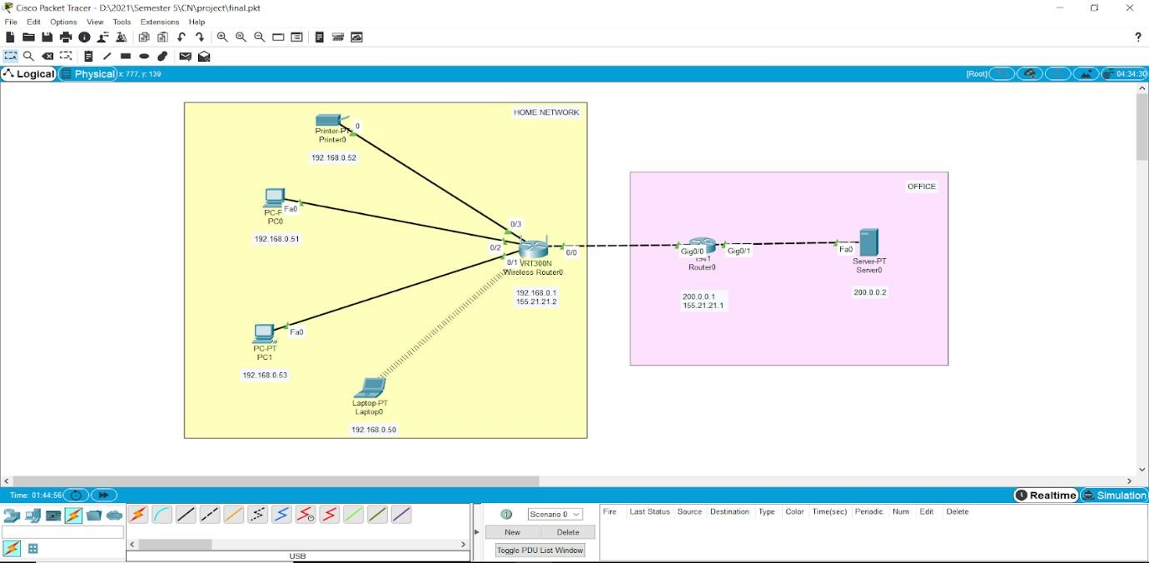

### 4.5 COMPONENTS

* Server (office)
* ISP Router (office)
* Wireless router
* Two PCs
* 1 laptop
* 1 printer

### 4.6 NETWORK DESIGN

**4.6.1 DHCP SERVER**

A DHCP Server is a network server that automatically provides and assigns IP addresses, default gateways, and other network parameters to client devices. It relies on the standard protocol known as Dynamic Host Configuration Protocol or DHCP to respond to broadcast queries by clients. Without it, the network administrator has to manually set up every client that joins the network, which can be cumbersome, especially in large networks.

For the desktop at home, which requires access from the office and the printer, the IP address will have to be configured manually.

**4.6.2 DYNAMIC ADDRESS ALLOCATION**

DHCP has a second database with a pool of available IP addresses. This second database makes DHCP dynamic.

When a DHCP client requests a temporary IP address, the DHCP server goes to the pool of available (unused) IP addresses and assigns an IP address for a negotiable period of time.

When a DHCP client sends a request to a DHCP server, the server first checks its static database. If an entry with the requested physical address exists in the static database, the permanent IP address of the client is returned.

On the other hand, if the entry does not exist in the static database, the server selects an IP address from the available pool, assigns the address to the client, and adds the entry to the dynamic database.

The DHCP server issues a lease for a specific period of time. When the lease expires, the client must either stop using the IP address or renew the lease. The server has the choice to agree or disagree with the renewal. If the server disagrees, the client stops using the address.

**4.6.3 ISP ROUTER**

ISP stands for "Internet Service Provider." An ISP provides access to the Internet. Whether we are at home or work, every time we connect to the Internet, our connection is routed through an ISP.

We need a router to connect multiple devices to the Internet. Since each device is routed through the same router, they will all share the same public IP address assigned by the ISP.

ISPs act as hubs on the Internet since they are often connected directly to the Internet backbone.

**4.6.4 WIRELESS ROUTER WITH SWITCH**

The wireless system on the router is used for providing wireless access to the laptop. The inbuilt switch in the router would be used for connecting the desktops. A LAN is created using the inbuilt switch and connecting all the PCs.

**4.6.4 NAT (NETWORK ADDRESS TRANSLATION)**

Network Address Translation is a feature of the wireless router that allows us to connect private/local networks to the internet.

NAT offers the dual functions of security and address conservation. Since it allows only a single device like a router as an agent to connect the home network to the internet, only one unique IP address is required to represent the entire local network. This provides security as the IP addresses of the local devices are not exposed to the internet.

To conserve IP addresses, LAN users make use of a range of private IP addresses for routing local traffic. When a local device like a laptop or PC needs to send traffic to the Internet, via the ISP, an address translation takes place. Therefore, the range of private IP addresses used by the company is translated to a single IP address.

**4.6.5 PORT FORWARDING**

Port forwarding is a technique that is used to allow external devices access to devices on private networks. It does this by mapping an external port to an internal IP address and port. We will have to configure this on the wireless router to connect the desktop to the remote office.

Port forwarding feature, which is configured on the router, is mapped with the LAN IP address

(192.168.1.0) of the desktop requiring remote access from the office. The user at the office would connect to the public IP address of the router (WAN interface IP address), using windows remote desktop client which would then forward the request to the internal desktop, which is configured to accept remote desktop connections.

**4.6.6 SECURITY**

A special certification program called Wi-Fi Protected Access (WPA) developed by Wi-Fi Alliance is used to secure the wireless network. We use the WPA-personal mode.

**WPA-Personal:** It is also referred to as WPA-PSK (pre-shared key) mode. It is designed for home and small office networks and doesn't require an authentication server. It is available on all three WPA versions. The WPA protocol implements the Temporal Key Integrity Protocol (TKIP) which employs a 128-bit per-packet key for each packet and thus prevents the types of attacks that compromised WEP. It also includes a Message Integrity Check, which is designed to prevent an attacker from altering and resending data packets.

**CHAPTER 5**

**IMPLEMENTATION**

### 5.1 CONFIGURATION

**5.1.1 IP NETWORK DESIGN**

|  |  |  |  |
| --- | --- | --- | --- |
| **Device** | **IP Address** | **Default Gateway** | **Interface** |
| **Server** | 200.0.0.2 | 255.255.255.0 | FastEthernet0 |
| **ISP Router** | 155.21.21.1 | 255.255.0.0 | GigabitEthernet0/0 |
| 200.0.0.1 | 255.255.255.0 | GigabitEthernet0/1 |
| **Wireless Router** | 155.21.0.1 | 255.255.0.0 | Internet |
| 192.168.0.1 | 255.255.255.0 | LAN |

**5.1.2 TCP IP CONFIGURATION FOR CLIENTS**

|  |  |  |  |
| --- | --- | --- | --- |
| **Device** | **IP Address** | **Default Gateway** | **Interface** |
| **Laptop0** | 192.168.0.50 | 255.255.255.0 | Wireless0 |
| **PC0** | 192.168.0.53 | 255.255.255.0 | FastEthernet0 |
| **PC1** | 192.168.0.52 | 255.255.255.0 | FastEthernet0 |
| **Printer0** | 192.168.0.51 | 255.255.255.0 | FastEthernet0 |

**5.2**

**NETWORK SETUP**

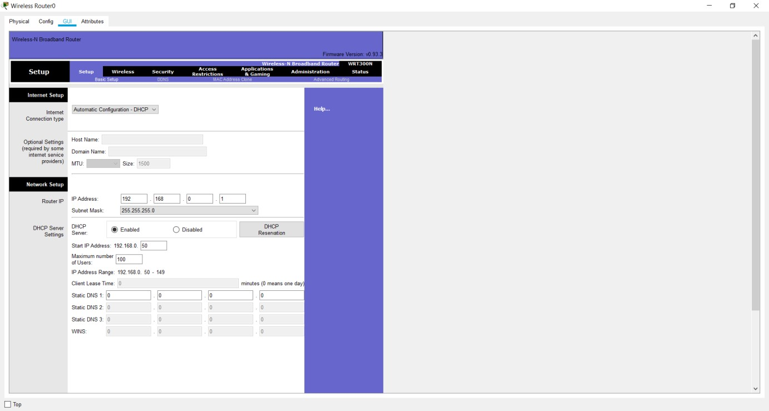

The above picture shows the Network setup of the wireless router. The IP address is 192.168.0.1 and subnet mask is 255.255.255.0. The start IP address is 192.168.0.50 and the maximum number of users has been mentioned as 100 since this is a home network.

Network setup means LAN setup. Already, we have a PC and three laptops in the LAN. We’ll assign them IP addresses either statically or dynamically (using a DHCP pool set up in the wireless router).

The default LAN network address given here is 192.168.0.0 with a subnet mask of 255.255.255.0. The first address in this network (192.168.0.1 by default) has been assigned to the LAN interface of the router. It has just been named IP address. Obviously, all the PCs in the LAN will use the LAN interface as their default interface (to communicate to hosts in outside networks).

Now, in the router’s network settings, you may choose to enable DHCP to dynamically assign IP addresses to the PCs. On the other hand, if you choose to disable DHCP, then obviously, you’ll have to configure static IP addresses on the PCs.

When you choose to enable DHCP, set the start address for the LAN pool, maximum hosts to be allowed in your LAN and the DNS server for the LAN. The PCs will receive addresses automatically from the pool.

Now, going the DHCP way: Ensure DHCP is checked.

Leave the IP address as 192.168.0.1 (This is the default LAN gateway address).

Set a start address of 192.168.0.50 and set maximum users to 100 (or any number of users you want) You can leave the DNS server entry as it is (0.0.0.0) or specify the address of a DNS server of your choice.

Scroll down and Save settings. Moving on, let’s enable DHCP on each PC for dynamic configuration. Go to the IP configuration tab for each PC and enable DHCP. Each PC should automatically obtain an IP address from the router.

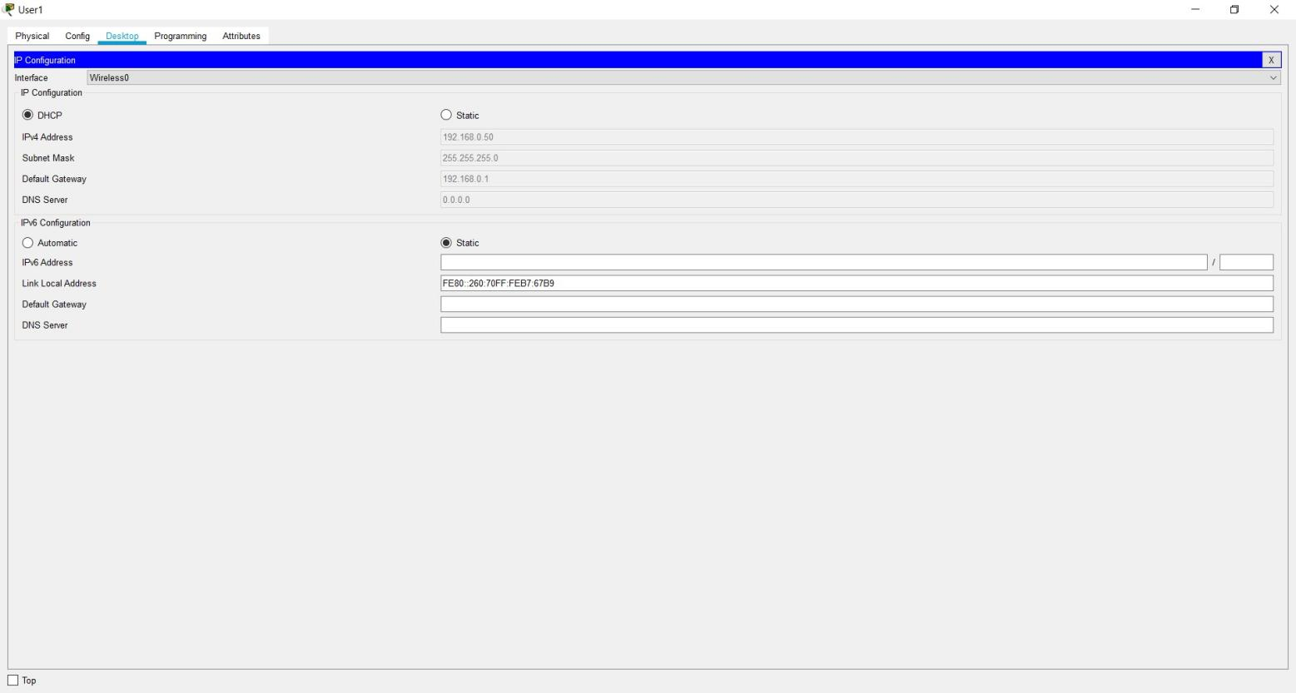

Now let's test our wireless LAN. Ping PC2 from PC1. Ping should succeed.

Try also to ping the LAN interface of the router from one of the PCs, say, PC1. It should be successful. Move on and add wireless security for the wireless LAN access.

### 5.3 SECURITY

The LAN network that has just been setup has no wireless security features enabled. If this a was a production network, this would mean an obvious security threat since this makes the network accessible to unauthorized users. Hence we need to implement some level of wireless security to our LAN.

Access the GUI of wireless router then click on Wireless tab. Under the Basic Wireless Settings sub tab, change the default wireless SSID to any name of your choice. I have named mine ‘myLAN ‘. After this, don’t forget to Save settings.

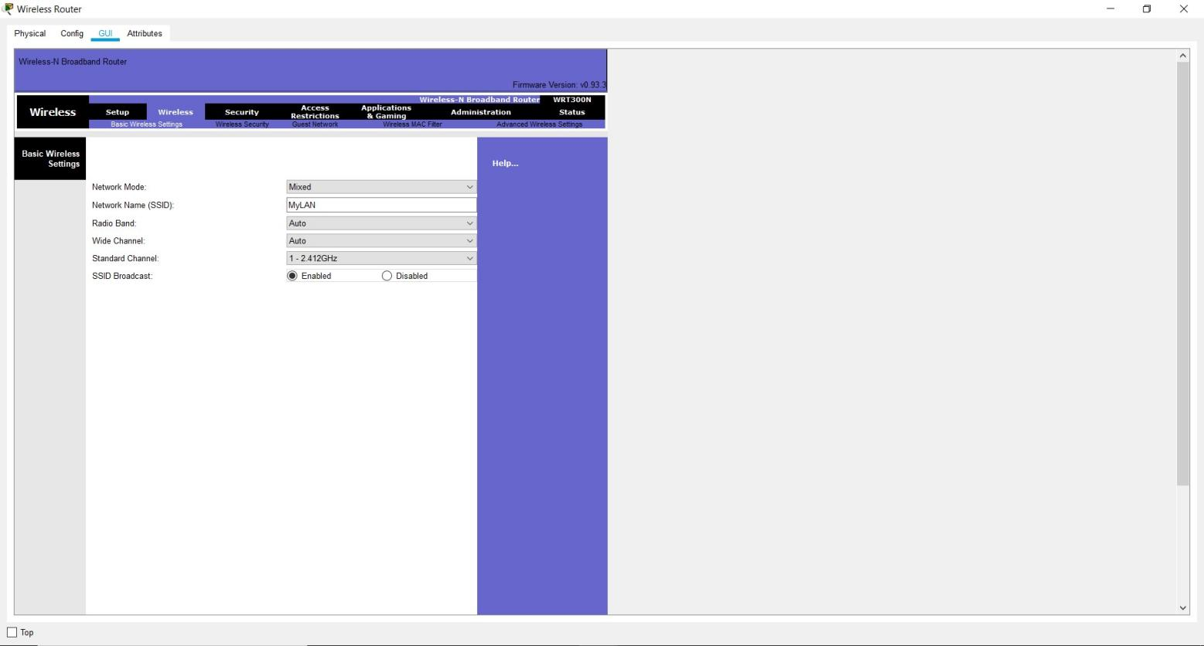

The acronym SSID stands for Service Set Identifier, and it’s the name of your wireless network (wireless LAN).

Still, in the Wireless tab, under the Wireless security sub tab, change security mode to WPA personal, then set passphrase field to a password of your choice. Scroll down and Save settings.

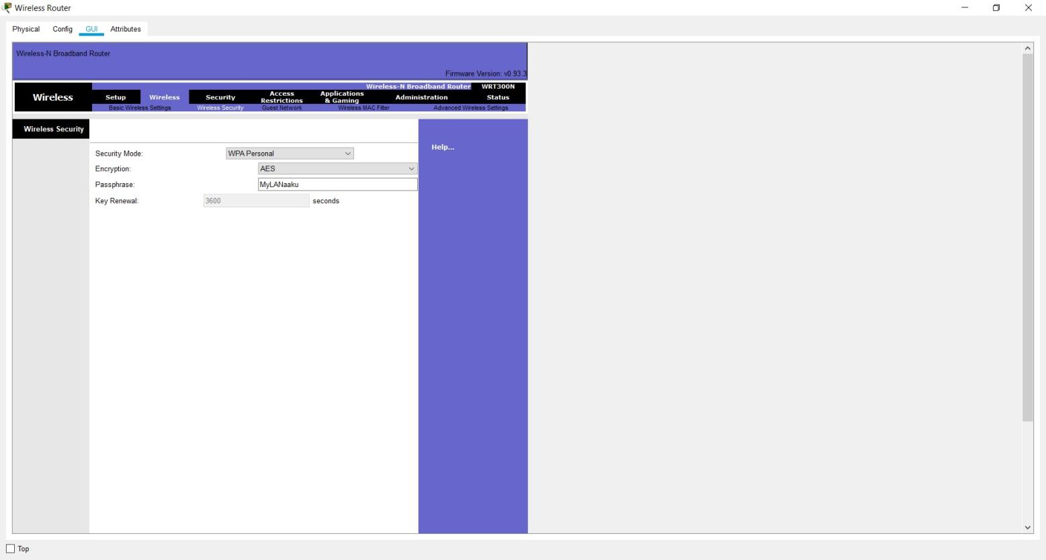

The LAN network is now secured for wireless access. To test whether it’s really protected, click Laptop1->Desktop->Wireless.

A new window appears that shows the now secured wireless network. Click connect. You can now see the name of the wireless network (my WIFI, in my case) and its signal strength. Site features listed include WPA1 PSK security feature.

Again, click connect, then provide the security pre-shared key for the Wi-Fi that you set, then connect. The laptop is now connected to the Wi-Fi network. We can see at the bottom right of the screen that the wireless network adapter on the laptop is active.

Next, we’ll look at how to set up internet configurations on the wireless router so that the PCs and laptop in the LAN can access the internet.

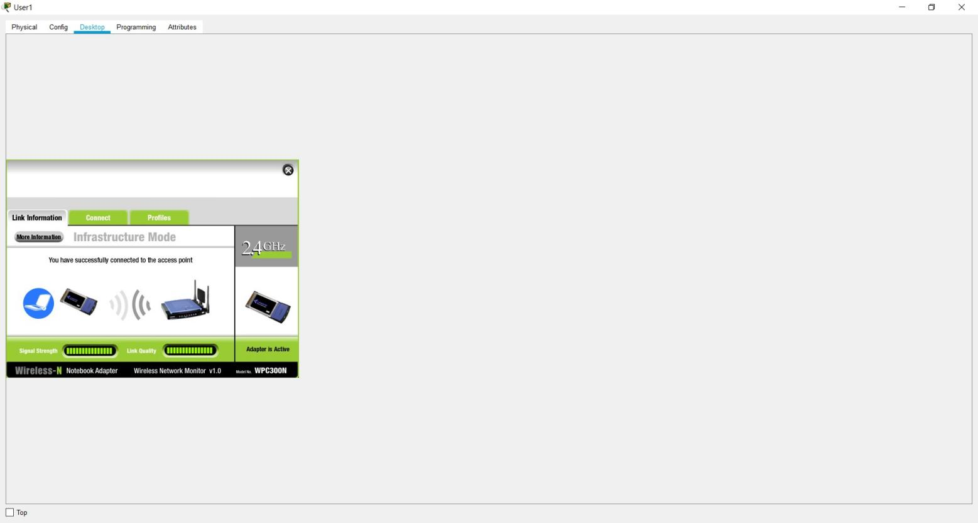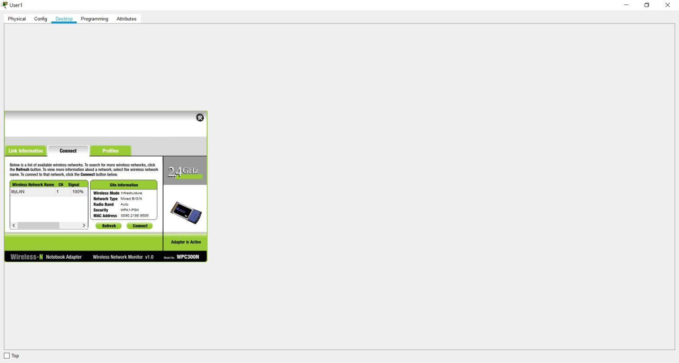

### 5.4 INTERNET SETUP

We’ll configure the internet interface on the router so as to connect our LAN to the internet. The interface may have the name ‘WAN interface ‘, suitably because it is the interface that allows devices in our LAN to access the internet.

Here, we’ll connect the internet interface to an ISP router which then connects to an internet server.

So now, access the Internet Setup tab on the GUI of the wireless router either by clicking on its icon or from the admin PC browser. We should remember the username name and the new password you set if you want to access it from the admin PC browser. To Set internet connectivity, we’ll need to set a static IP address on the interface or set interface as a DHCP client so that it will be assigned an address dynamically by the ISP router. If we choose to configure a static IP address for the internet interface, we can also specify the default gateway and a DNS server of your choice. Here we had the internet interface address configured by DHCP, we set the internet interface as a DHCP client. A DHCP server will be configured on another device, such as the ISP router.

For now, we’ll set the internet interface to act as a DHCP client with the DHCP server configured on the ISP router First configure IP addresses and a DHCP server on an ISP router.

The commands used are:

ip dhcp pool mypool net 155.21.0.0 255.255.0.0 default-router 155.21.21.1 dns-server 0.0.0.0

Now make the internet interface a DHCP client by enabling DHCP on it.

To verify DHCP configuration, click on the wireless router icon, then go to the Config tab.

Pick DHCP. The interface is now configured with an IP address from the pool set in the ISP router. Next, we have to configure static or dynamic routes in the ISP router for the devices in the wireless LAN to gain access the internet server:

Commands for static route: ip route 192.168.0.1 255.255.255.0 fa0/0

Lastly, assign an IP address to the internet server, then try to reach the server from a host in the LAN.

**CLI of the ISP router with the above commands:**

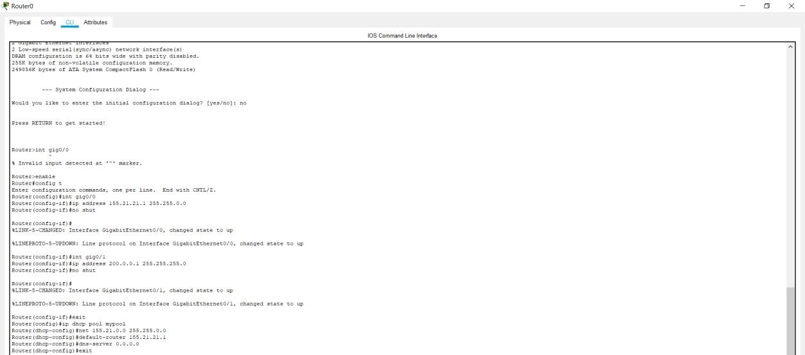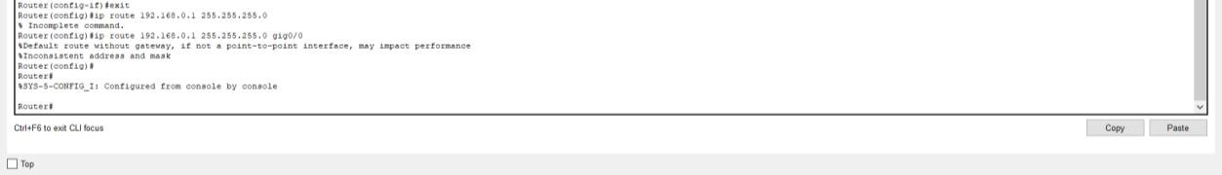

**The configuration of the Wireless router showing the DHCP settings and IP address:**

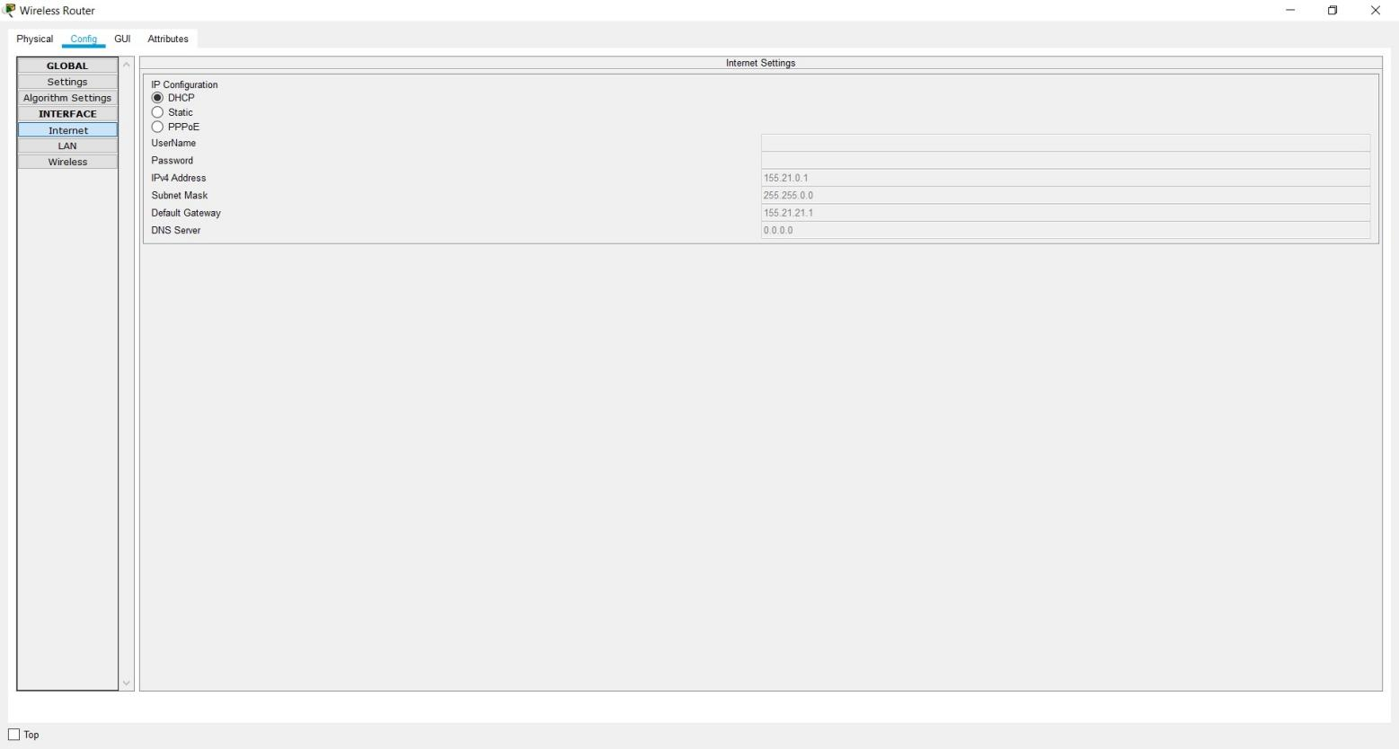

## CHAPTER 6

**EXPERIMENT RESULTS AND ANALYSIS**

### 6.1 RESULTS

**Web browser of PC0 to show active internet connection:**

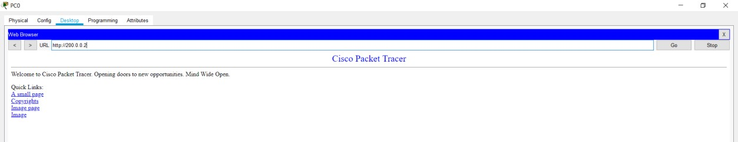

**CLI of Laptop0 with IP address 192.168.0.50:**

1.

Pinging the

office server (200.0.0.2)

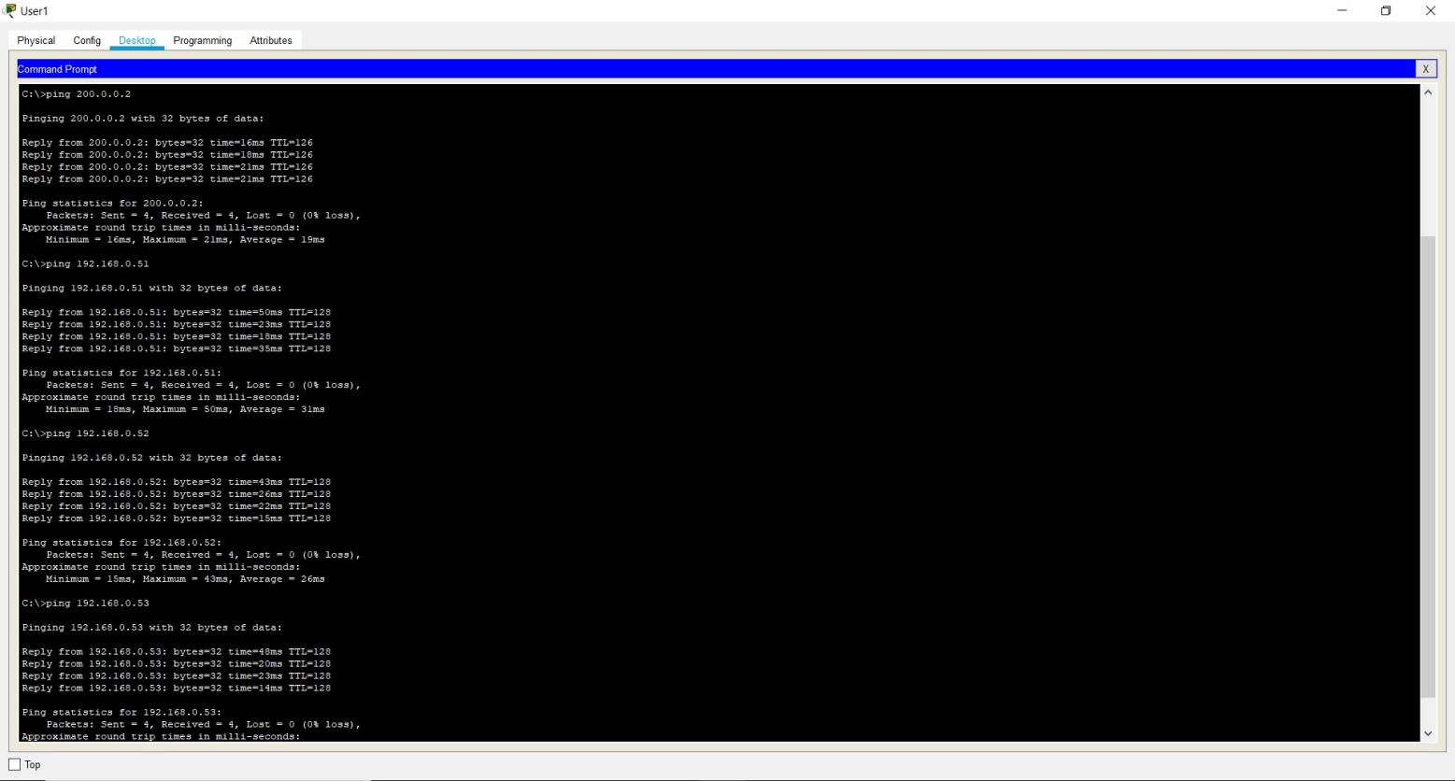

1. Pinging the printer (192.168.0.51)
2. Pinging the PC1 device (192.168.0.52)
3. Pinging the PC0 device (192.168.0.53)

**CLI of PC0 with IP address 192.168.0.53:**

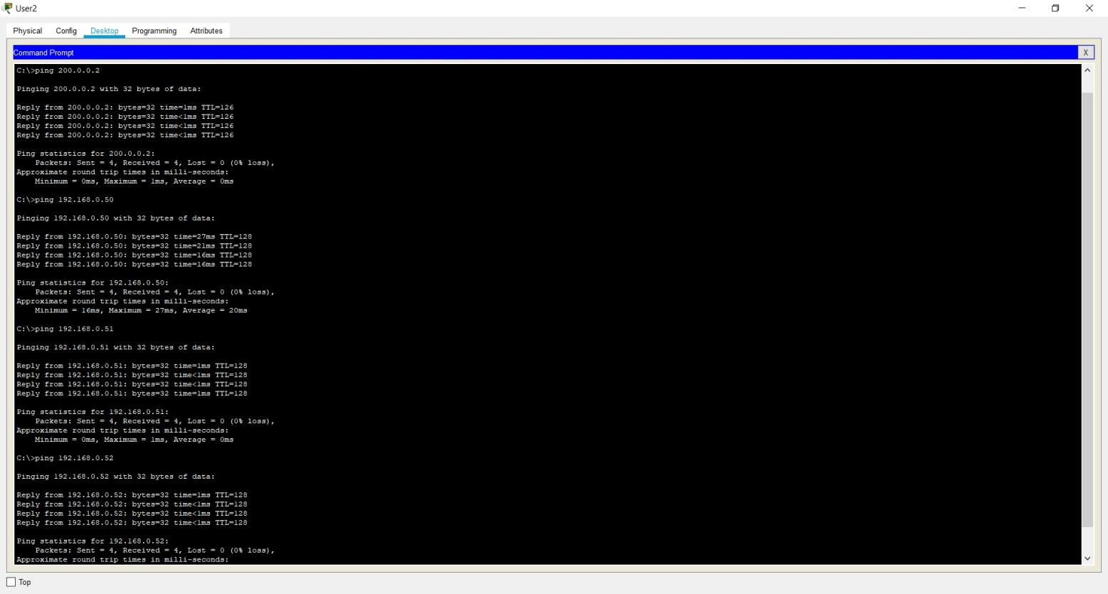

1. Pinging the office server (200.0.0.2)
2. Pinging the Laptop0 device (192.168.0.50)
3. Pinging the printer (192.168.0.51)
4. Pinging the PC1 device (192.168.0.52)

**CLI of PC1 with IP address 192.168.0.50:**

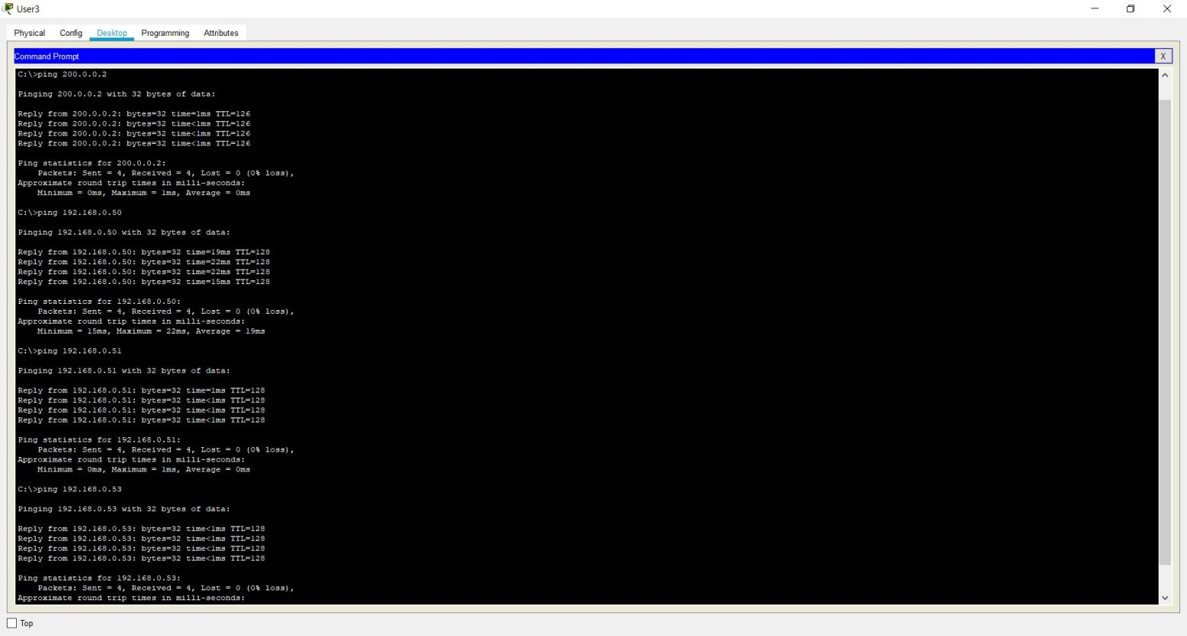

1. Pinging the office server (200.0.0.2)
2. Pinging the Laptop0 device (192.168.0.50)
3. Pinging the printer (192.168.0.51)
4. Pinging the PC0 device (192.168.0.53)

### 6.2 RESULT ANALYSIS

The command **show ip dhcp binding** is used to display the following information:

|  |  |
| --- | --- |
| Output field | Description |
| IP Address | The IP addresses currently in the binding database. |
| Client ID/Hardware address | The hardware address of the client. |
| Lease expiration | The time when this lease will expire. |
| Type | The type of lease. |

The command **show ip dhcp pool** is used to display the information of:

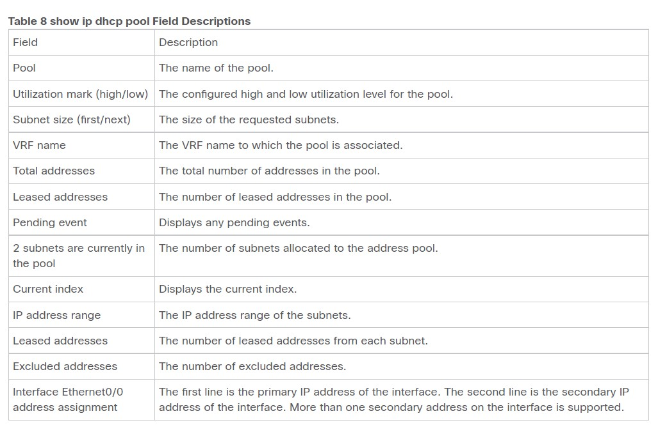

**CLI of the ISP router to show the above commands:**

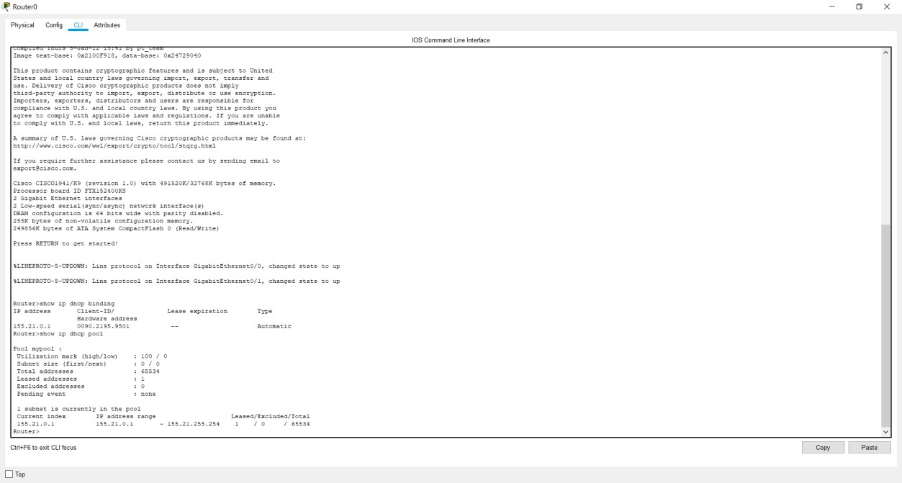

### 6.3 CONCLUSION AND FUTURE WORKS

Hence, we have successfully established a home wireless network design that connects three users to the internet in a hybrid wired-wireless connection. The laptop is successfully connected wirelessly to the internet, and the two PCs are connected via a wired internet connection. All three users are connected to the printer via the wireless router.

**6.4 FUTURE WORKS:**

* We can replace the parallel printer with a wireless Bluetooth printer which can connect to the internet via WIFI which will reduce cable cost.
* If the number of users increases then the network complexity will increase, hence we can use routers ,access point and switches to make sure complex network is clean ,easy to understand and repair in case of faults.

**CHAPTER 7**

## REFERENCES

1. Designing a Wireless Network, Jeffrey Wheat, Randy Hiser, Jackie Tucker,

Alicia Neely, Andy McCullough (Technical Editor)

1. TCP/IP Protocol Suite, Behrouz A. Forouzan
2. [https://www.section.io/engineering-education/implementing-network-addresstranslation/](https://www.section.io/engineering-education/implementing-network-address-translation/)